Advanced : 2D Shape Editor

Reload this article and prepare it for printing.
(removes banner ad and menubar and sets new width for page)
This article was last updated on Thursday, March 29, 2001
Written by:
Chris Willis
chris.willis@sierra.com
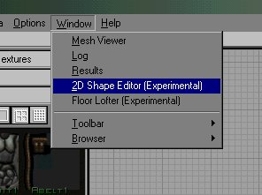
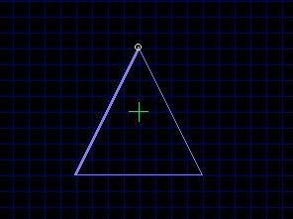
1.
Once in UnrealED pull down the "Window Tab" and goto the " 2D editor "
2.
After you"ve opened it you will see a blue triangle, each side of the triangle can be edited by pulling on the corners of the triangle or by inserting a vertex under the " Vertex Tab ". Each vertex inserted can be moved to make the shape more interesting. Remember: When you use this tutorial think of the object as one half of the whole object you want to make because you will be revolving it, not lofting it. The shape being made will rotate around the green crosshair so the crosshair needs to be at what will be the imaginary center of the finished shape ( the green crosshair needs to be on the lefthand side of the object, ok? ). :)
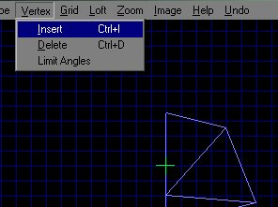
3.
Goto the "Loft Tab " then to " Revolver ". There you"ll be able to choose how many sides you want your shape to have. I used the default of " 6 ".
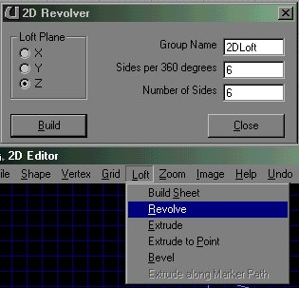
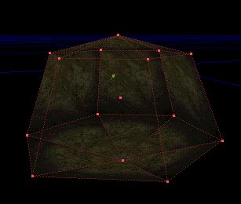
4.
Hit Build ,and there you go! Your custom shape is made.

